**UNFinished Business Employment Application User Manual**

**Using The Interface**

The interface consists of a 1 page form divided with multiple sections for each type of information. The left-side bar of the application includes clickable links that will take the user to the specific section of the form.

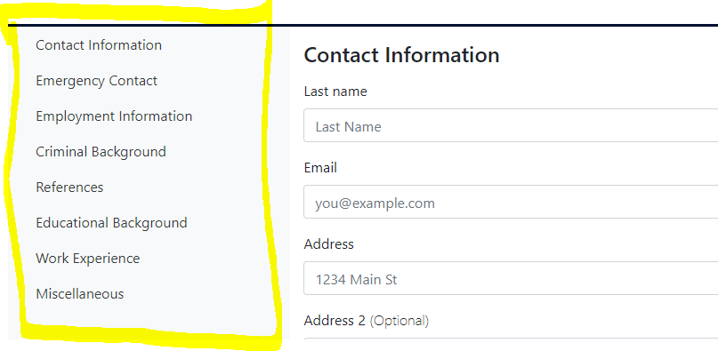

The top-right of the application form has a blue box with a question mark icon in it that allows the user to configure the layout of the page by changing the background color, text color, font size and audio for each field heading.The user will complete each section with the appropriate information in each field. After going through each section and filling in information, at the end the user will see a link to view the application acknowledgement and a submit button. Once the submit button is clicked, form validation will occur and verify that all required fields have a value.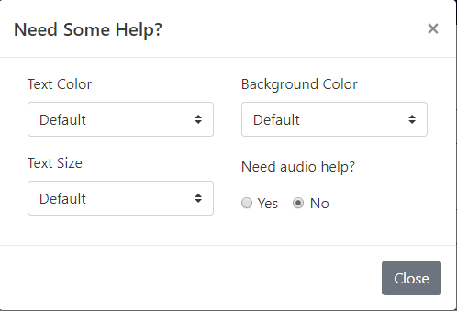



Fields within the application:

1. **Contact Information section**
   1. Last Name, First Name, Middle Name - Allows the applicant to enter their name. Only character values are allowed and these fields are required.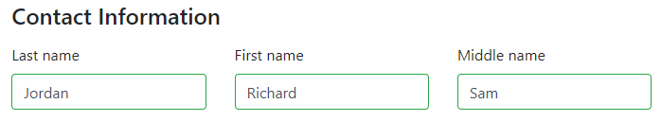
   2. Email - Allows the applicant to enter the email address they want to be contacted at. Allows for any values to be entered but must be a valid email address to include the ‘@’ symbol for the entry to be accepted.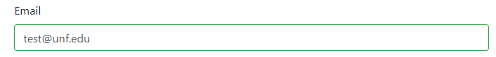
   3. Address - Allows the applicant to enter their current street address. Characters and numbers allowed in this field and the first address field is required while the second field is an optional field to allow for address in use by an apartment number or suite number.  
      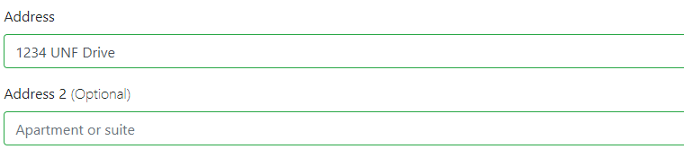
   4. State - Allows the user to select their current state they live in. This field is a drop-down menu that allows the user to select from all 50 US states sorted in alphabetical order.  
      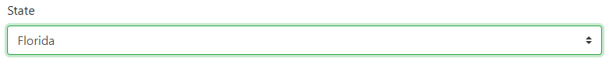
   5. City - Allows the user to enter the current city they live in. This field allows for characters to be entered with no minimum length.  
      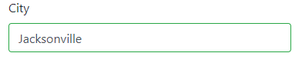
   6. Zip code - Allows the user to enter the zip code they live in. The values this field takes are numbers and the user must enter 5 numbers for the zip code.  
      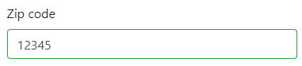
   7. How long have you lived at your current address? - This field allows the user to select how many years and months they have lived at the current address entered. Both of the fields are drop-down fields to let the user select how many years and months they have lived at the current address, “years” is the left box and “months” is the right.  
      
   8. Telephone Number - This field allows the user to enter their phone number to be contacted. This field allows for only numbers to be entered and requires no dashes or separators in the number.  
      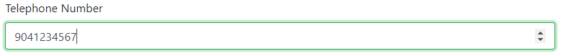
   9. Mobile Number - This field allows the user to enter their mobile phone number to be contacted. This field allows for only numbers to be entered and requires no dashes or separators in the number. The user can use the same number from the “Telephone Number” field if both these values are the same.  
      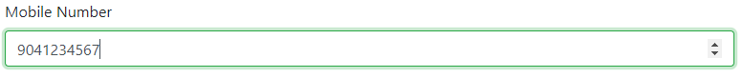
   10. Social Security Number - This field allows the user to enter their social security number. This field allows for only numbers to be used and has up and down arrows in the box to let the user increase or decrease the number value.  
       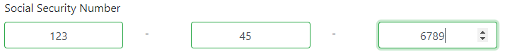
   11. Check if 18 or older - This field is a check-box that is required to be marked if the applicant wishes to work for the company. This field only allows for the user to ‘click’ in the box to mark the field as valid for the applicant being 18 years or older.  
       
2. **Emergency Contact section**
   1. Last name, First name, Middle name - This field allows for the user to enter in someone else's name that they wish to be contacted for an emergency. Characters are only allowed in these fields to enter a valid name.  
      
   2. Email - Allows the applicant to enter the email address they want to be contacted in case of an emergecy. Allows for any values to be entered but must be a valid email address to include the ‘@’ symbol for the entry to be accepted.  
      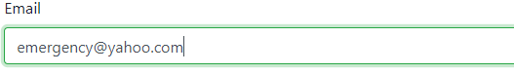
   3. Address - Allows the applicant to enter the street address of their emergency contact. Characters and numbers allowed in this field and is required.  
      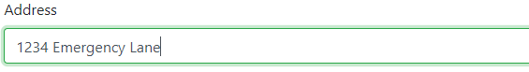
   4. State - Allows the user to select the state the emergency contact lives in. This field is a drop-down menu that allows the user to select from all 50 US states sorted in alphabetical order.  
      
   5. City - Allows the user to enter the city the emergency contact lives in. This field allows for characters to be entered with no minimum length.  
      
   6. Zip code - Allows the user to enter the zip code the emergency contact lives in. The values this field takes are numbers and the user must enter 5 numbers for the zip code.  
      
   7. Telephone Number - This field allows the user to enter the emergency phone number to be contacted. This field allows for only numbers to be entered and requires no dashes or separators in the number.  
      
   8. Mobile Number - This field allows the user to enter the emergency mobile phone number to be contacted. This field allows for only numbers to be entered and requires no dashes or separators in the number. The user can use the same number from the “Telephone Number” field if both these values are the same.  
      
   9. Relation - This field allows the user to enter the relationship to the emergency contact. The values for this field are characters.  
      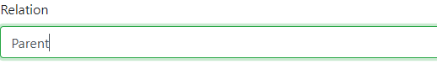
3. **Employment Information section**
   1. Desired Salary - This field allows for the user to enter their salary expectations for the position. Numbers are only allowed for this field and there are up and down arrows in the box to let the user increase or decrease the number value.  
      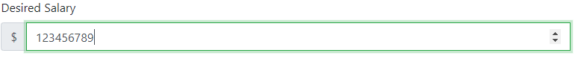
   2. Position Applied For - This field allows the user to enter what position they are applying for at the company. This field allows characters and numbers for the example of “Software Developer 3”.  
      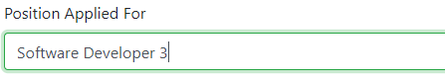
   3. Available Start Date - This field allows the user to select a date when they are available to start work. Only numbers are allowed in the “mm/dd/yyyy” format and the box has an arrow that allows for a drop-down calendar to select a date from.  
      
   4. Available to work nights? - This field allows the user to select if they can work during the night. This field contains radio buttons where the user must select one or the other, both cannot be selected.  
      
   5. How many hours a week can you work? - This field allows the user to input how many hours per week they are able to work. This field requires a number value to be entered only and has up and down arrows within the box to increase or decrease the number value.  
      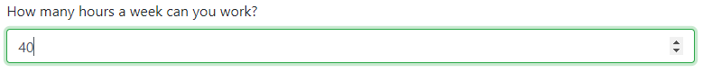
   6. Have you ever been fired from a job? - This field allows the user to select if they have been fired from a previous job. This field contains radio buttons where the user must select one or the other, both cannot be selected.  
      
   7. What days are you available to work? - This field allows the user to select which days they can work. This is a check-list of the days of the week where the user can select multiple values out of the list.  
      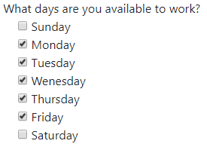
4. **Criminal Background section**
   1. Have you ever been convicted of a crime? - This field allows the user to state if they have been convicted of a crime before. This field includes 2 radio buttons where the user can only select one option. If the user chooses “No”, they will not be prompted with additional information. If the user chooses “Yes”, they will be given more fields to provide information regarding the crime.  
      
   2. Date - This field allows the user to enter the date that they have been convicted of a crime on. The user must enter a date format with numbers only in the “mm/dd/yyyy” format. There is also a drop-down calendar to select a date if the user clicks on the down arrow on the right side of the box.  
      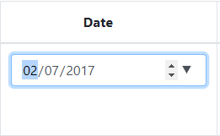
   3. Misdemeanor/Felony - This field allows the user to select if the crime was a misdemeanor or a felony. This is a drop-down menu with both of these options that the user must select.  
      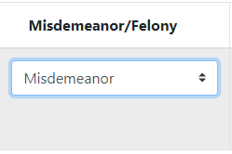
   4. Description - This field allows the user to describe the crime charge. This field allows characters and numbers to be entered for a description.  
      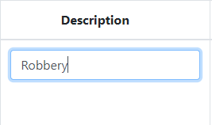
   5. Confinement/Probation/Community Service - This field allows the user to select the penalty of the crime charge between the options of confinement, probation, or community service. This field is a drop-down menu with these options listed and requires a selection of one of the options.  
      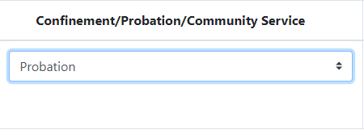
   6. Months/Years - This field allows the user to enter how long the penalty of the crime was. The top box is how many years and the bottom box is how many months, both of these fields require a number value and have up and down arrows on the side of the box to help increase or decrease the number value.  
      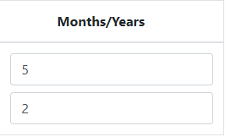
5. **References section**
   1. Name - This field allows the user to enter the name of the reference. The top box is for the first name and the bottom box is for the last name of the reference, both of these fields require characters to be entered.  
      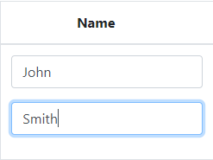
   2. Title - This field allows the user to enter the title or job position of the reference they are using. This field allows for characters and numbers to be entered.  
      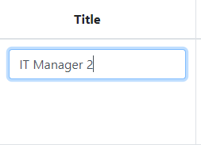
   3. Company - This field allows the user to enter the company the reference has worked for. This field allows for characters and numbers to be entered.  
      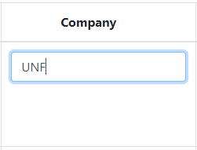
   4. Address - This field allows the user to enter the address associated with the reference. This field allows for characters and numbers to be entered.  
      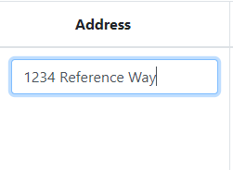
   5. Telephone - This field allows the user to enter the reference’s phone number to be contacted at. This field allows for numbers to be entered without the need for dashes or separators for the phone number.  
      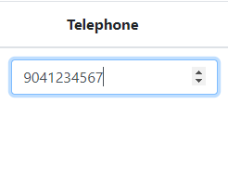
   6. Email Address - This field allows the user to enter the email address of the reference to be contacted. This field allows the use of characters and numbers and must include the ‘@’ symbol for a valid email to be entered.  
      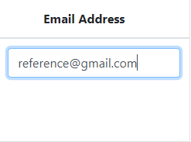
6. **Education Background section**
   1. School Type - This field allows the user to enter the type of education they have received. This is a drop-down menu with the options “High School”, Undergraduate”, “Graduate”, “Postgraduate”, or “Professional”. One of the fields must be selected for the educational background.  
      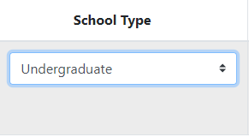
   2. School Name - This field allows the user to enter the name of the school they attended. This field allows for characters and numbers to be entered for a input from the user.  
      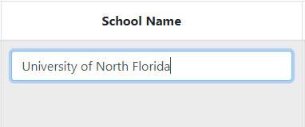
   3. Location - This field allows the user to enter the location of where the school they attended is located. The top box is a drop-down menu that lists all 50 states in alphabetical order and the bottom box is for the city that it is located in. The city requires characters to be entered.  
      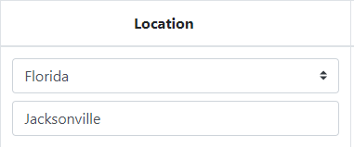
   4. Major/Degree/Certificate - This field allows the user to enter the type of accomplishment they received from their education entry. This field is a text box that allows for the input of characters and numbers.  
      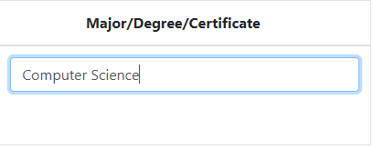
7. **Work Experience section**
   1. Job Title - This field allows the user to enter the job title that they have had at a previous employer. This field takes characters and numbers for a valid entry.  
      
   2. Employer’s Name - This field allows the user to enter the name of the employer of where that position was held. This field allows the characters and numbers to be entered.  
      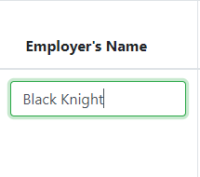
   3. Email - This field allows the user to enter the email that they have/had at the previous employer. This field allows for characters and numbers to be entered but must contain the ‘@’ symbol for a valid email address.  
      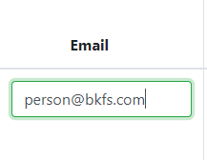
   4. Telephone - This field allows the user to enter the telephone number of the previous employer. This field allows for numbers to be entered and does not need dashes or separators for the phone number.  
      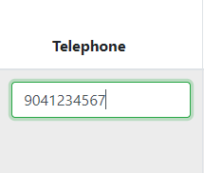
   5. Address - This field allows the user to enter the address of where the employer is located. This field allows for characters and numbers to be entered.  
      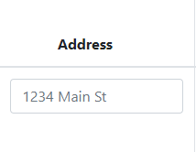
   6. City/State/Zip Code - These fields allows the user to complete the address of the previous employer by entering the City, State, and Zip code. The top box is the city that the employer is located in and requires characters to be entered, the middle box is the state that the employer is located in and is a drop-down box that has all 50 states in alphabetical order where 1 entry must be selected, and the bottom box is the zip code that the employer is located in and requires numbers to be entered for a valid entry.  
      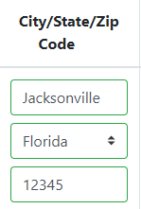
   7. Duration - This field allows the user to enter the length of employment from the employer. The top box is the number of years and the bottom box is the number of months. Both of these boxes require a number value and have up and down arrows on the right-side of the box to increase or decrease the number value.  
      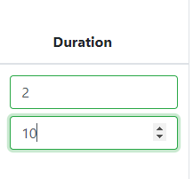
8. **Miscellaneous section**
   1. Have you ever served in the military? - This field allows the user to indicate if they have previous military experience. There are 2 radio buttons for ‘Yes’ and ‘No’ that the user must select one of the options. If the user selects ‘No’ no other information will be needed, if the user selects ‘Yes’ there will be additional information requested from the user.  
      
   2. How many years did you serve? - This field allows the user to enter the number of years they have served in the military. This field requires a number value to be entered and includes up and down arrows on the right-side of the box to increase or decrease the number value.  
      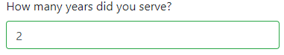
   3. Honorable Discharge? - This field allows the user to state if they left the military on a honorable discharge or not. There are 2 radio buttons for ‘Yes’ and ‘No’ the user must select one option.  
      
   4. Which Branch? - This field allows the user to select which branches of the military they have served in. This is a list of values with the branches of the military where the user can select either 1 or multiple values from the list.  
      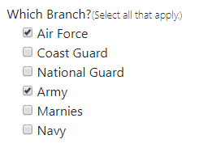
9. **Submission section**
   1. Application Acknowledgement - This section states that upon submission, the user agrees to the Application Acknowledgement set by the company. Upon clicking the ‘Application Acknowledgement” hyperlink, the user can scroll down the page and read the acknowledgement in its entirety.  
      
   2. Submit button - This button allows the user to submit the information they have provided in the form and acknowledges that the applicant has read the ‘Application Acknowledgement’ section. Once the submit button has been clicked, the form will validate all the information that has been entered to make sure that each entry is valid. If some fields are missing or invalid in the application, the form will prompt the user and highlight the sections that are invalid in the color red to be completed accurately.

